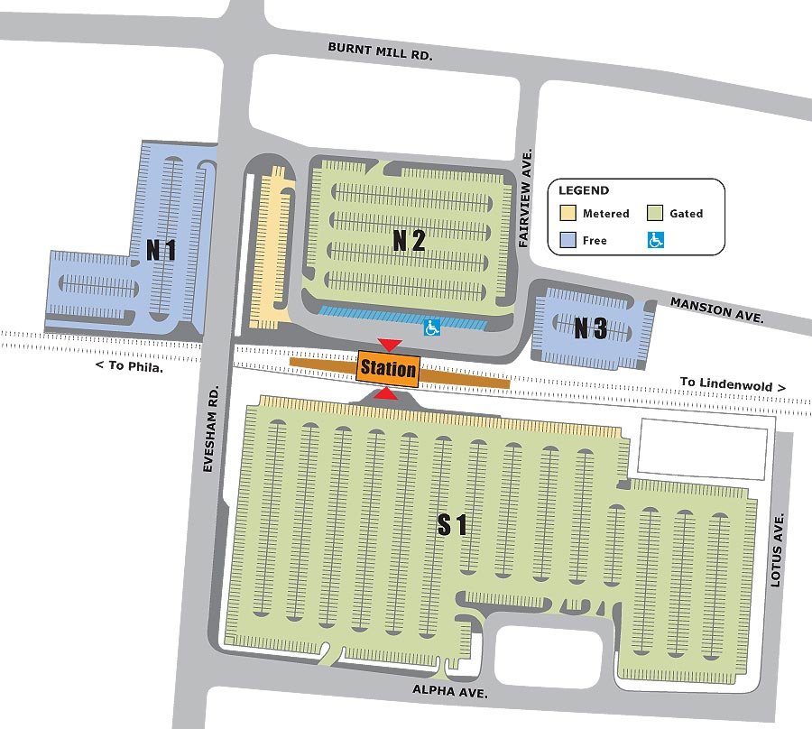
ASHLAND PARKING LOT REPAVING SCHEDULE
LOT N1
Scheduled for repaving
4/18 – 4/22
Weather permitting
LOT S1
Scheduled for repaving
4/25 – 4/29
Weather permitting
LOT N2
Scheduled for repaving
5/16 – 5/20
Weather permitting
LOT N3 &
METER AREA
Scheduled for repaving
5/9 – 5/13
Weather permitting
LOT S2
Scheduled for repaving
5/2 – 5/6
Weather permitting
S2

